ROOM RESERVATION AT SWISS-GARDEN HOTEL BUKIT BINTANG
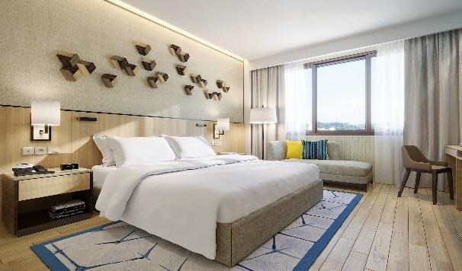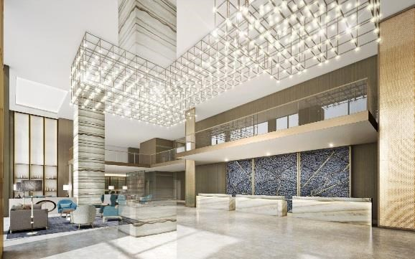

EXCLUSIVELY FOR :-
INTERNATIONAL CONFERENCE ON MATERIAL ENGINEERING AND NANO TECHNOLOGY ON 2ND – 5TH DECEMBER 2019
RESERVATION DETAILS

Guest Name
Company Name
Contact Number
Contact Email
Arrival Date
Departure Date
No. of Night (s)
No. of Room (s) / Room Type
Number of person (s) – Adult / Child
Room Rate | HOTEL ROOM  Deluxe (Single) @ RM200.00net per room/per night + 1 Breakfast  Deluxe (Twin) @ RM240.00nett per room / per night + 2 Breakfast  “All rates quoted are including SST (Sales & Services Tax) of 6%, effective on 1 September 2018.”
Billing Instructions | Personal Account
Credit card number / Expiry date
Cancellation Policy | No shows or cancellation less than 72 hours (3 Days) prior to arrival date will result in a penalty of full payment charged.  Cancellations made more than 72 hours (3 days) prior to arrival date will be free-of-charge (no fees incurred).
Remarks
Check In Time / Check Out Time | Our check-in time is from 3 pm onwards. To guarantee your room (s) for early arrival, it is recommended to pre-block the room the night before with a full day charge. The check-out time is 12 pm. Any extension of check-out time will be subject to availability.

TERMS & CONDITIONS
All rates quoted in Ringgit Malaysia.

Under the gazetted Tourism Tax Act 2017, all foreign guests, even if on shared accommodation with a Malaysian, will be levied a Tourism Tax of RM10.00 per room/per night for stays from 1st September 2017. This amount is not included in the booked room price and will be paid directly by the guest at the hotel.

Upon check-in, Malaysians producing proof of valid Identity Cards; and Malaysian Permanent Residents producing proof of valid MY PR Cards will be exempted if the room is registered to them and not on sharing basis with a foreigner.

GUARANTEE POLICY
All reservations must be guaranteed by a valid credit card.

Thank you for choosing Swiss-Garden Hotel Bukit Bintang. We look forward to welcoming you.

BANK ACCOUNT DETAILS
Bank : RHB Bank Berhad
Account Name (Payee) : Allstar Odyssey Sdn Bhd
Account Number : 2-14129-0031014-9
Address : Kuala Lumpur Main 1, Level 1, Tower 2, RHB Centre, 426, Jaln Tun Razak, 50400 Kuala Lumpur
SWIFT Code : RHBBMYKL

EMAIL TO:-
- reservation@shbb.swissgarden.com
- azlina.ahmad@shbb.swissgarden.com
- carol.yap@shbb.swissgarden.com
I, *Passport/NRIC :
hereby authorise Swiss-Garden Hotel Bukit Bintang to bill:
Room Only
Room inclusive breakfast
Others
or specific charges only (please specify)
incurred at Swiss-Garden Hotel Bukit Bintang to following credit card.
Cardholder’s Name: (as appears on the credit card)
Credit Card No. : - - - Expiry Date : / Month/Year)
COPY OF THE FRONT AND BACK OF THE CREDIT CARD WITH A CLEAR SIGNATURE IS REQUIRED
Card Type : Visa MasterCard Amex JCB Diners
CVV No. : (found at the back of the credit card)
Signature : Date: / / DD/MM/YY)

WITH COMPLIMENTS WHEN STAYING WITH US
l Wi-Fi l Gym I
Yours sincerely,
Azlina Ahmad (Lynn) – Senior Sales Manager
H/P: 012 – 611 5325
Email: azlina.ahmad@shbb.swissgarden.com
117, JALAN PUDU, 55100 KUALA LUMPUR, MALAYSIA. TEL : +603 – 2141 3333
Website : www.swissgarden.com
OWNED BY ALLSTAR ODYSSEY SDN. BHD. (Co. No. 1277735-U)
MANAGED BY SWISS-GARDEN INTERNATIONAL SDN. BHD. (Co. No. 217032-M) A MEMBER OF PJ DEVELOPMENT HOLDINGS GROUP

